H.T No
Regulations:
A18


Sreenidhi Institute of Science and Technology
(An Autonomous Institution)
Code No: 7AC02 Date: 07-Jan-2019 (FN)

B.Tech I-Year I-Semester End External Examination, Dec-2018/Jan-2019 (Regular)
NETWORK ANALYSIS (ECE)

Time: 3 Hours Max.Marks:75

Note: a) No additional answer sheets will be provided.
b) All sub-parts of a question must be answered at one place only, otherwise it will not be valued.
c) Missing data can be assumed suitably.

Part - A Max.Marks:25

Answer all QUESTIONS.

1. | Explain the concept of super node with example. | [3M]
2. | Define and explain Form factor. | [3M]
3. | Derive an expression for co-efficient of coupling. | [3M]
4. | State and explain superposition theorem. | [3M]
5. | Explain h-parameters in two port network. | [3M]
6. | Explain the transient response of series RL circuit for sinusoidal excitation. | [2M]
7. | Define and explain resonance frequency of parallel RLC resonance circuit | [2M]
8. | State and explain reciprocity theorem. | [2M]
9. | Compare natural response and forced response in a circuit. | [2M]
10. | Distinguish between nodal analysis and mesh analysis. | [2M]
Part – B Max.Marks:50
ANSWER ANY FIVE QUESTIONS. EACH QUESTION CARRIES 10 MARKS.

11. | a) | Determine the nodal voltages for the circuit shown in Figure.1  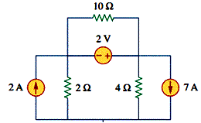  Figure.1 | [5M]
 | b) | Calculate the power supplied or absorbed by each element of the circuit shown in Figure.2.  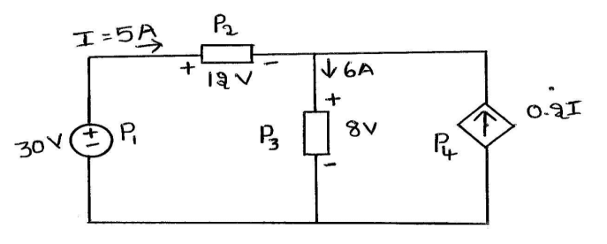  Figure.2 | [5M]
12. | a) | Derive the expressions for the bandwidth of series resonating circuit and obtain its relationship with Q-factor. | [5M]
 | b) | Explain the terms RMS value and average value for a periodic waveform. | [5M]
13. | a) | Explain dot convention with all possible combinations. | [5M]
 | b) | An iron ring has a mean length of 50cm has an air gap of 1mm and a winding of 200 turns. If Relative permeability is 400 when a current of 1A flows in the winding, determine the flux density. Neglect leakage and fringing. | [5M]
14. | a) | State and explain Maximum power transfer theorem and derive the condition for maximum power transfer from source to load | [5M]
 | b) | Find the value of R_{L} to be connected between the terminals A and B for maximum power transfer from source to load for the circuit shown in Figure.3.  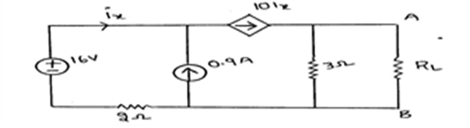  Figure.3 | [5M]
15. | a) | Determine h-parameters for the network shown in Figure.4  Figure.4 | [5M]
 | b) | Find Y₁₁ and Y₂₁ of the network shown in Figure.5.  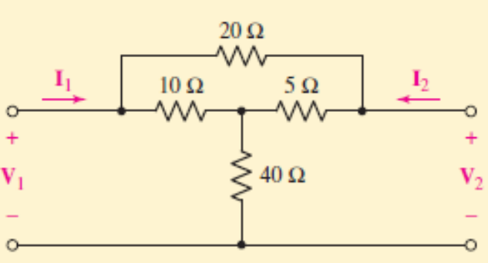  Figure.5 | [5M]
16. | a) | For the circuit shown in Figure.6, switch is moved from position 1 to 2 at t=0. Find the voltages V_{R}(t) and V_{c}(t).  Figure.6 | [5M]
 | b) | Determine the two mesh currents i₁ and i₂ in the circuit of Figure.7. There is no energy initially stored in the circuit.  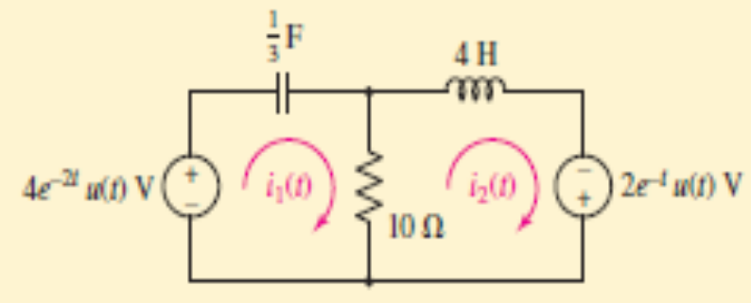  Figure.7 | [5M]
17. | a) | Derive equation for resonance frequency of series RLC circuit. | [5M]
 | b) | Calculate current flowing through 5Ω resistor across A and B in below Figure.8.  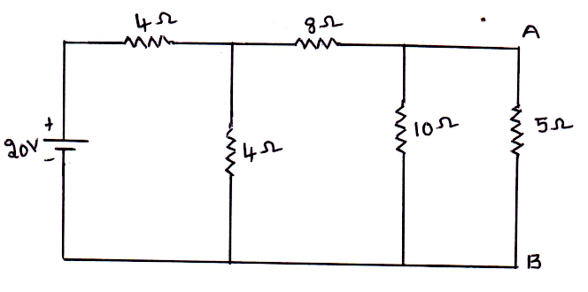  Figure.8 | [5M]
18. | a) | For the circuit of Figure.9, use superposition to compute the current i_{x}.  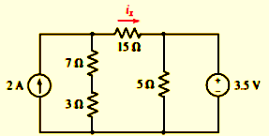  Figure.9 | [5M]
 | b) | List the formulae that convert from Z-parameters to Y-parameters. | [5M]

-- 00 -- 00 –

